Sheela Ahmed

David Long

Introduction to Imaging and Video Systems: Homework 1

February 15, 2015

1. One main property of light is the photons that travel which are measured as wavelengths. A main part of electromagnetic radiation is the behavior of the electric and magnetic waves that oscillate perpendicular to each other in the form of transverse waves [1]. Photons can be included in both wave and particle nature topics due to their importance as particles and their behavior at certain wavelengths. The amount of energy a photon has determines the color of the visible light – high energy for blue light and low energy for red light. This leads to another property, which is the speed of light. The speed of light through a vacuum (and air) is 3 x108 m/s. The movement of photons through various mediums depends on the speed of light, and this speed causes wavelengths to oscillate in the way that they do.

Another property of light is its ability to refract when passing through different mediums such as glass, water and diamond. Wavelengths of the light bend more or less depending on the density difference compared to a vacuum. This refers back to the behavior of photons as they travel through different mediums. The oscillation depends on the speed at which the photons are traveling, which in turn leads to the wave-particle duality.

Along with refraction, diffraction is another property of light that also attributes the bending of light as it passes through an opening. Referring to the slit experiment, as light passes through the slit, it bends around the corners and creates a circular wave-like pattern. The photons disperse outwards – similar to refraction, where they bend – depending on the wavelengths. The behavior of the particles of light through diffraction is dependent on the wavelengths, and the wave nature as the light passes through the slit is dependent on the behavior of the particles [2].

1. Sinusoidal curve with wavenumber, k = 3.75, Amplitude = 0.5, and phase offset, ϕ=π radians:

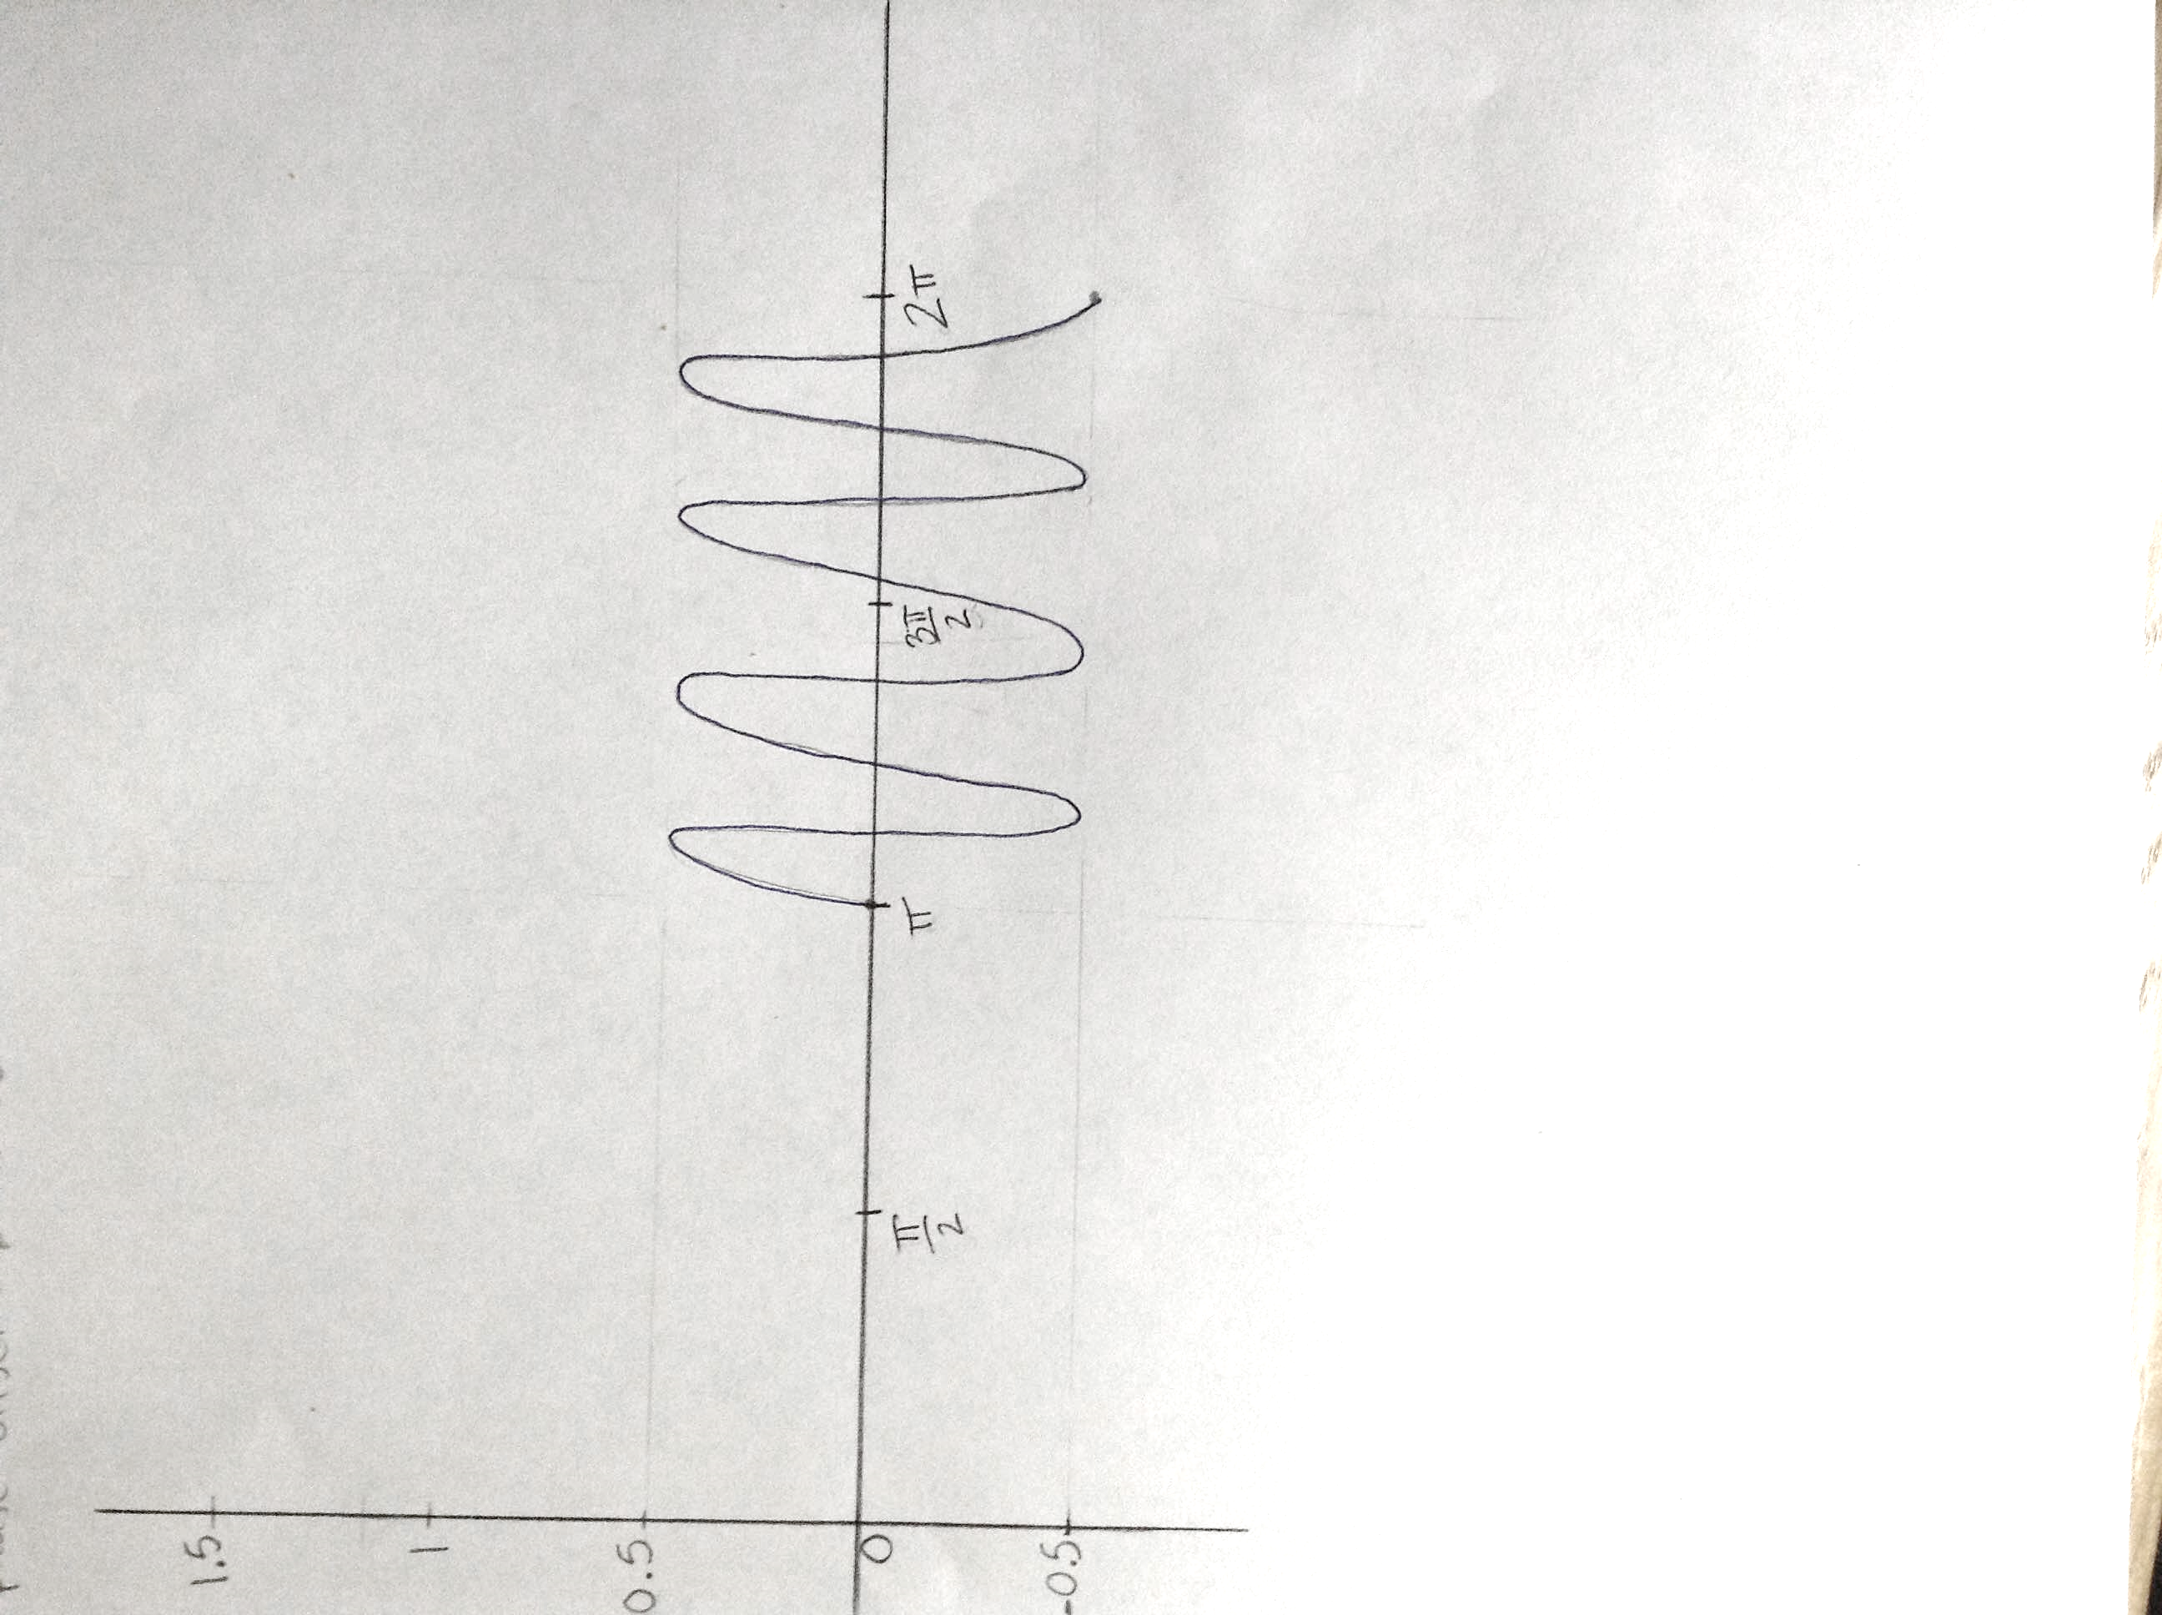

1. If both a sine and cosine function have the same wavenumbers, the phase in fractional wavelengths is ¼. This is because they are shifted 90 degrees from one another, which would be the angular phase. Given that they both have the same wavenumbers, a cosine function will start on the y-axis – at 0 degrees – at a constant, for example 1, and the sine function will not reach that constant until it’s at 90 degrees. Since 90 degrees is a fourth of one whole cycle of the unit circle of 360 degrees, the phase of one fractional wavelength would be ¼.
2. On January 30, 2016, the distance between Earth and Jupiter was 688, 200, 000 kilometers (688.2 trillion kilometers) which is equal to 4.6 AU. (An AU is an astronomical unit where 1 AU is the distance from the Earth to the Sun [3]). On May 22, 2016, the distance between Earth and Jupiter would be approximately 769 trillion kilometers, or 5.15 AU. Therefore, it would take 86.7 minutes for the laser light to make the trip to Jupiter and back to Earth.

One main factor that changes constantly is the distance between Earth and Jupiter due to their positions in their orbit around the Sun. Since planets don’t orbit in perfect circles and instead have elliptical orbits, the distance varies at different times in the year. So for this question, it has to be known where Earth and Jupiter are in their orbit on the specific dates.

1. 1. Frequency is equal to the speed of light divided by the wavelength (c/λ) and the speed of light in air or a vacuum is 3 x 108 m/s. Since the range of wavelengths is 400nm – 700nm, the range of wave frequencies is 7.5 x 1010 Hz – 4.3 x 1010 Hz.
   2. Through glass, the range of wavelengths would be 360nm – 465nm.
   3. Through glass, the range of wave frequencies would remain the same (7.5 x 1010 Hz – 4.3 x 1010 Hz ) because if it were to change, the color of the light would change as well [4]. So when light passes through a medium, the wavelength changes but the frequency remains the same.
2. Using the equation, y = (mλD)/a, the widths of the primary diffraction peaks are:
   1. Wavelength = 450nm: 8.4mm
   2. 525nm: 9.8mm
   3. 600nm: 11.2mm
   4. 675nm: 12.6mm

By looking at these results, it can be concluded that the larger wavelength led to a larger width in the diffraction peak, which leads to more dispersion of the light. So the image quality would be better for the short wavelengths – in this question, 450nm and 525nm – compared to the longer wavelengths because the light does not disperse as far away from the center.

1. There would be 5 interference peaks in the primary diffraction envelope.
   1. The color that is refracted the most is blue, whereas red is the least refracted. This is due to the shorter wavelength of the blue, which is around 400nm. As visible light passes through a prism, the differences in wavelength affect the angles at which certain colors are refracted. Since blue has a shorter wavelength – compared to red, which has a wavelength of 700nm – its refraction is greater and it bends at a greater angle, causing it to bend further as it leaves the prism.
   2. Through a diffraction grating, red light is displaced the most due to its larger wavelength. This relates back to question 6, when measuring the widths of the diffraction peaks. The larger wavelengths led to larger widths, which means they disperse more after passing through the diffraction grating. Another way to look at this is by using the equation given in class, dsinθ = mλ. It can be seen that since the wavelength and the angle are directly related to each other, a larger wavelength will lead to a larger angle. This will lead to more displacement of the red light as it leaves the diffraction grating.

Works Cited

[1] <http://www.cs.mun.ca/av/old/teaching/cg/notes/light_inclass.pdf>

[2] Prof. Stephen A. Nelson. (2014). *Properties of Light*. Tulane University “Properties of Light and Examination of Isotropic Substances”. Web. <http://www.tulane.edu/~sanelson/eens211/proplight.htm>

[3] The Planets. (2010-2016). “Distances between Planets”. Web. <http://theplanets.org/distances-between-planets/>

[4] Ted Montgomery. “Light Wavelength, Frequency, and Color”. Web. <http://www.tedmontgomery.com/remarks%5C08.1-12/optics/index.html>